Team Number-26

Nikhil Jaglan(18103118)

Vaibhav Pandey(18103072)

Harshit Singhal(18103114)

Sahil Kaul(18103111)

# Supervisors :

Prof. Amandeep Kaur and Dr. Rajesh Bhatia.

# Overview

Surveillance security is a very tedious and time-consuming job. We will build a system to automate the task of analyzing video surveillance. The role of CCTV videos has overgrown. CCTV cameras are placed all over the places for surveillance and security. We will analyze the video feed and identify any abnormal activities like theft identification, violence detection, and detection of the chances of explosion.

# Goal

To develop a deep learning model which will accurately identify abnormal activities such as theft, violence and terrorist attacks from CCTV video footage and also to build a web application for this having the functionalities like login, signup and a chat bot as well.

An example has been shown below.



# Features of model

Deep neural networks are generally used for computer vision, image classification, and object detection tasks. In this project, we will extend deep neural networks to 3-dimensional for learning spatio-temporal features of the video feed. For this video surveillance project, we will use a spatio-temporal autoencoder, which is based on a 3D convolution network(CNN). The encoder part extracts the spatial and temporal information, and then the decoder reconstructs the frames. The abnormal events are identified by computing the reconstruction loss using Euclidean distance between original and reconstructed batch.

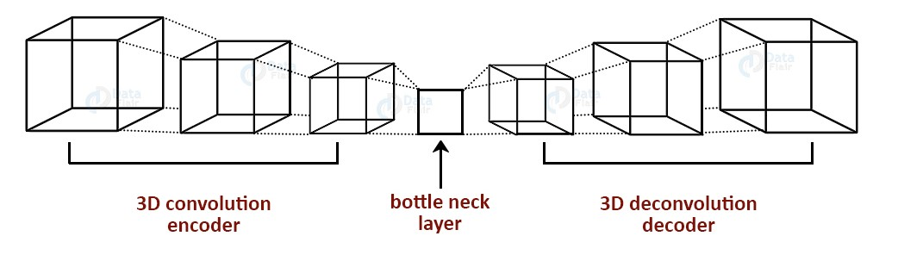

We will also be building the web application of it and will be linking the model with the web application. The front-end application will be built using reactjs having a chatbot for helping users browse through the front-end application features and to resolve queries posted by users. It will also have the functionality of login and signup . The user will feed the CCTV video clipping in the front-end application which will report to the user about the abnormal activities of the particular clippings.

## **Requirements**

1. CHUK Avenue Dataset

We will be using CHUK Avenue Dataset for training the deep learning model. This dataset contains 16 training and 21 testing video clips. The video contains 30652 frames in total.

The training videos contain video with normal situations. The testing videos contain videos with both standard and abnormal event

#### 

#### UCSD pedestrian Dataset

This dataset contains videos with pedestrians. It includes groups of people walking towards, away, and parallel to the camera. The abnormal event includes:

* Non-pedestrian entities
* Anomalous pedestrian motion patterns

We will be using GPU’s for training the model on dataset, CNN, encoder-decoders, computer vision algorithms, html, css and javascript.